Lesson 1 Homework | LT 2.1 | 3-11 odd, 12, 28-29

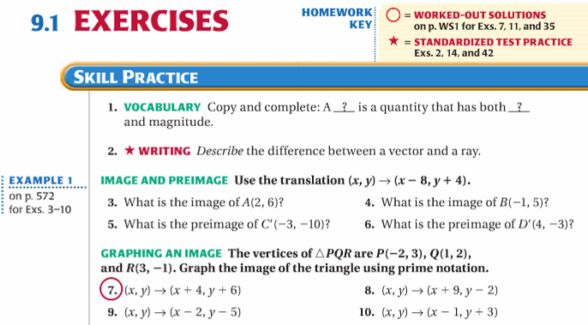

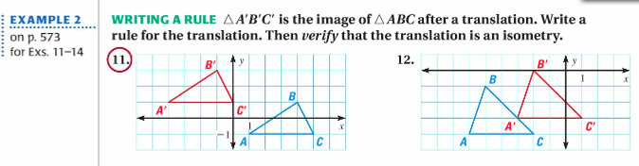
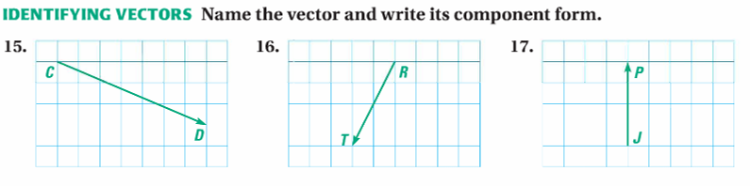

Lesson 1 Homework | LT 2.1 | 3-11 odd, 12, 28-29

